**[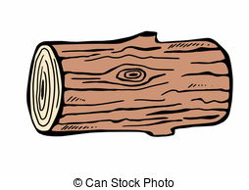](http://www.google.cz/url?sa=i&rct=j&q=&esrc=s&source=images&cd=&cad=rja&uact=8&ved=0CAcQjRxqFQoTCIvKodf3v8gCFQu8FAodiwIAeQ&url=http://www.canstockphoto.com/illustration/wood-logs.html&psig=AFQjCNGX99ymP3BX7OZcubDW3h-m2Fie6w&ust=1444842437862528)**

1. **Příslovce**

**[](http://www.google.cz/url?sa=i&rct=j&q=&esrc=s&source=images&cd=&cad=rja&uact=8&ved=0CAcQjRxqFQoTCJSy-obzv8gCFcddFAodwooFHg&url=http://www.123rf.com/photo_13630219_illustration-of-a-green-caterpillar-cartoon.html&psig=AFQjCNEh-0pEy3qUpBQsSU-hTqCy9-vZpw&ust=1444841092833412)**

1. **Podstatná jména**